**Instrument Control Flow Chart**Abhinay Kumar | 11-05-2024

**Instrument Control Flow Chart**

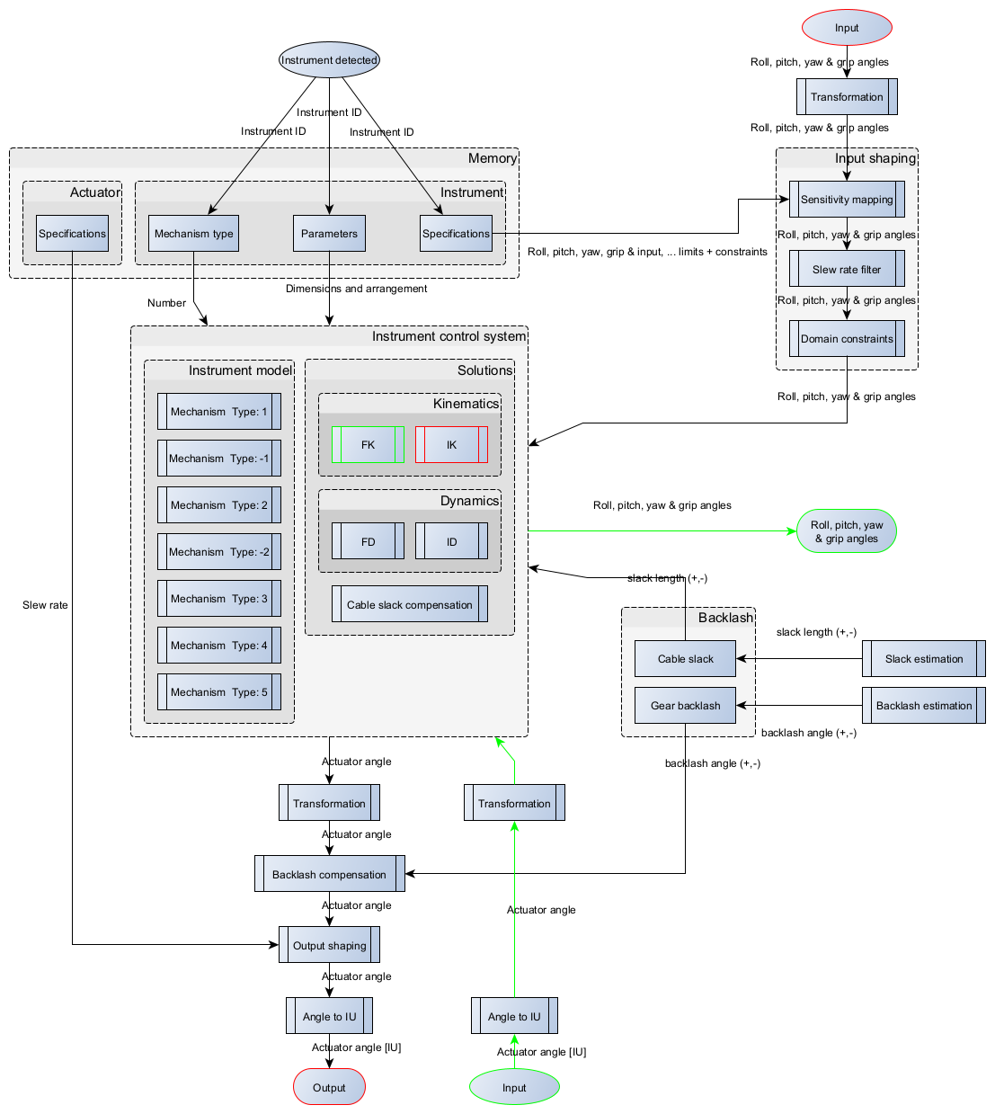

**Inverse Kinematics Flow Chart (**Process Output**):** For calculating actuator commands.

**Forward Kinematics Flow Chart (**Process Input**)**: For Visualization and feedback, during disable / enable

**Input Shaping Flow Chart (**Process Output & Input**)**: For Limiting, scaling / manipulating user command

